Rotary Club of Kathmandu Mid-Town
Breakfast Chatter
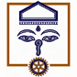

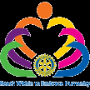

13 April 2012 The Weekly Bulletin of Rotary Club of Kathmandu Mid-Town Bc-4.13/011-12

District: 3292 Web: www.rotarymidtown.org.np Club Id : 26776
APRIL IS MAGAZINE MONTH
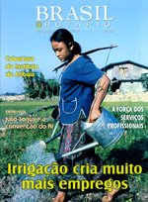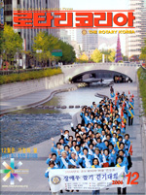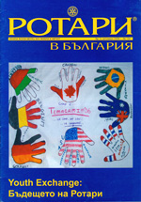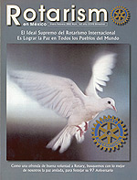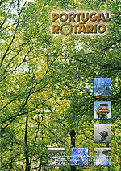
The Rotary World Magazine Press consists of 32 magazines from Africa, the Americas, Asia, Australia, and Europe that inform, inspire, and entertain in 23 languages. In addition to The Rotarian, Rotary’s English-language flagship publication, it offers magazines such as Vida Rotaria (Argentina), Rotary in Bulgaria, and The Rotary-no-Tomo (Japan)

Wishing you all a Very Happy New Year
2 0 6 9
Let there be happiness and happiness every moment every day throughout the YEAR.

6 April, Friday
Mr Kedar Bahadur Adhikary was our guest speaker. He was talking on a very important topic of the day, that is, protecting city environment.

Weekly Meetings and Programs :
Date | Program/Speaker | Program/Topics of Presentation
13 April 2012 | No meeting | Happy New Year 2069
20 April 2012 | Sue Lee | Sheffield - the greenest city in Europe!
27 April 2012 | Sirjana Rana | Healthy Heart and Jayanti Foundation

Guests from Rotary Club of Calgary West:
On Friday morning of 4 May a team of around 30 guests (Rotarians/spouses/friends) led by Rtn Karl Herzog of Rotary Club of Calgary West, Canada will be visiting us during the Club meeting. There will be a lot of fellowship and interaction.
Source: Rtn Dr Isabella Bassignana Khadka

RI Board Decision:
“You will be pleased to note that the Board at its recent January 2012 meeting took the following decision”:
1. Agrees that Bhutan meets the criteria for extension as specified in Rotary Code of Policies
section 18.020;
2. Agrees to open Bhutan for the extension of Rotary clubs;
3. Agrees that subject to the provisions of RI bylaws section 15.010, all clubs in Bhutan shall be
grouped in District 3292 so that the district shall be constituted as follows:
District 3292: The countries of Bhutan and Nepal.
4. Requests the general secretary to notify the clubs in the above district of this decision;
5. Notes that any objections by the clubs in the present District 3292 to the above changes
must reach the RI general secretary within 45 days from the mailing date of this decision.
Source: DG Basu Dev Golyan

Nobel Peace Prize winner Muhammad Yunus, a keynote speaker at the 2012 RI Convention,
talks to The Rotarian:
Nobel Peace Prize winner Muhammad Yunus, known as the “banker for the poor”, began transforming lives while an economics professor at the University of Chittagong in Bangladesh. What began as personal microloans to poor women in nearby villages grew into Grameen Bank, which today has more than 2,500 branches throughout the country. Grameen Bank has helped launch or expand the businesses of more than 8 million borrowers – 97 percent of them women. Yunus, a keynote speaker at the 2012 RI Convention, recently spoke with Warren Kalbacker, a frequent contributor to The Rotarian. Here is an excerpt of the interview.
The Rotarian: In 1976, you introduced the concept of microcredit, which involves providing loans of as little as a few cents to individuals. Many businesspeople might be puzzled as to how lending such small amounts could be effective.
Yunus: Microcredit started in one village in Bangladesh. I was teaching economics, and the country was going through famine. I was frustrated because the economic theories I taught in the classroom didn’t have any meaning in the lives of poor people. I thought I’d try to do something to help individuals in the village next to the university campus. I noticed loan sharking in the village – people lending money to the poor with terrible conditions attached. The sharks took control of peoples’ lives. I thought I could solve this problem by lending money myself. I visited those who were borrowing from the loan sharks, and I made a list of 42 names. The total money they owed was the equivalent of US$27. I put the money in their hands to pay off the loan sharks so they could be free. When I did that, everybody got excited. If such a small amount of money could make so many people so happy, I thought I should do more of it.
The Rotarian: Your concept of social business involves raising and investing capital, then managing the enterprise for a return. Yet you specify that there will be no profit-taking. Aren’t you offering something like two cheers for capitalism?
Yunus: People think if you take out the profit incentive, businesses cannot survive. That’s absolutely wrong. There are many other incentives. In a social business, I make other people happy. By making other people happy, I become happy. That incentive is something economists don’t understand. I am introducing that. I’m not walking out on capitalism; I insist that capitalism is misinterpreted. It’s based on a single type of business: profit-making. It’s imbalanced. If you add the social business leg to the capitalist system, then it becomes stable. When a business is run only to maximize profit, people are too busy to examine or solve social problems, so they let governments take care of those problems. But we citizens are capable of solving problems ourselves. That’s what the social business can do. (……. cont’d)
Source: Dan Nixon/Rotary International News

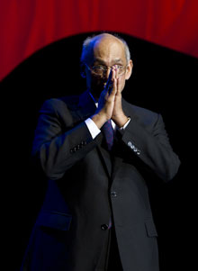
If we are trying to bring about change, it’s not enough to say, “My way is the better way.” We have to be listening and watching, not just talking. We can only help others if we reach out with an open mind – and with the knowledge, the commitment, and the perseverance to deliver on what we promise.
RI President Kalyan Banerjee

On Lighter Side : Click here ⇩


A thought for the day:
There may be times when we are powerless to prevent injustice,
but there must never be a time when we fail to protest.
- Elie Wiesel

Do you have an old penny ?
1793 penny fetches $ 1.38 mil at Florida auction: A once-cent copper coin from the earliest days of the US Mint in 1793 has sold for a record $ 1.38 million at a Florida auction. James Halperin of Texas-based Heritage Auctions told the Associated Press on Saturday that the sale was “the most a United States copper coin has ever sold for at auction.” The coin was made at the Mint in Philadelphia in 1793, the first year that the US made its own coins. Heritage officials said in a news release that the name of the buyer was not revealed but that he was ‘a major collector’. One of the coin’s earliest owners was a well-known Baltimore banker, Louis E. Eliasberg, Sr.
Source: The Rising Nepal

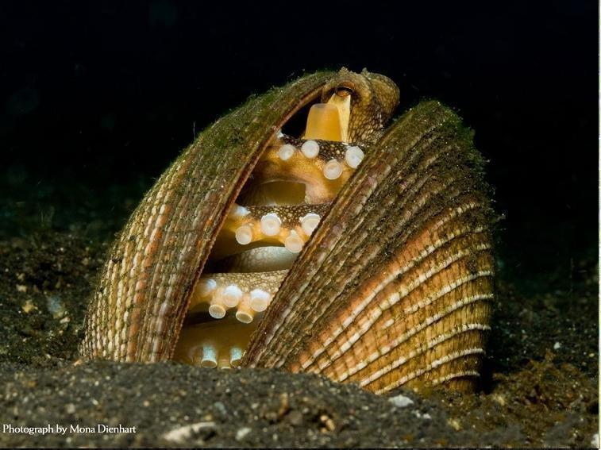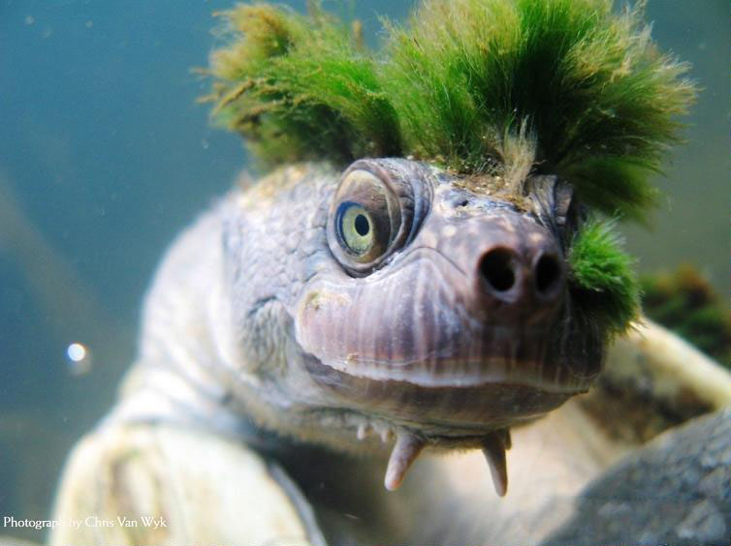

Please send project/activity information, suggestions and photos etc to :
BC Editor: RR Shrestha email: rryes@wlink.com.np

13 April 2012 The Weekly Bulletin of Rotary Club of Kathmandu Mid-Town bc-4.13/011-12

